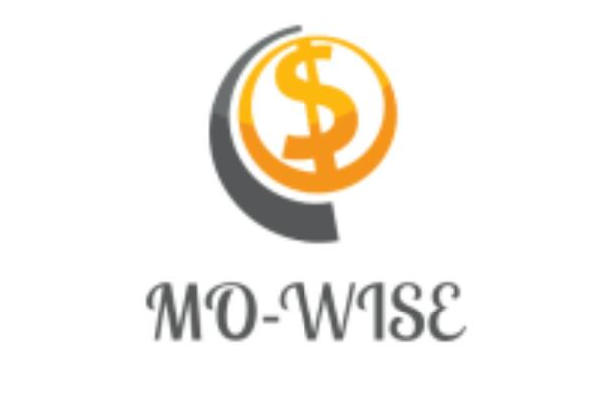**TEAM KRUSHERS**

**Mo-Wise application**

THE KENYA HIGH SCHOOL

Team members:

Jean Gloria, Joy Koki, Claudia Chepng’etich, Patience Wanjiru and Gail Auma.

Contents

EXECUTIVE SUMMARY 3

Company Summary 6

Product Description 8

Market analysis 9

Strategy implementation 12

# 

# EXECUTIVE SUMMARY

**Problem description**

Youth in Kenya lack proper monetary management skills such as saving and healthy investment ideas. They have minimal education on the benefits of saving and hence end up misusing money given to them through unhealthy spending habits such as non-profitable businesses and gambling.

**Solution**

Due to the above stated problem, we as Team Krushers decided to create an application that provides financial literacy and links the user to financial institutions e.g. cooperatives and banks where they can get one on one information on savings and investments. After saving they are provided with healthy investment ideas and market opportunities by financial experts from the institutions.

**Team Members**

Team Krushers comprises of;

**Market Description**

Our application targets the 9.9 million youth in Kenya (between 15 to 24 years) out of which 67% have smart phones that can access the internet and 80% of them have poor spending habits.

**Product Description**

Our application is a financial application that provides a platform for educating the youth on proper monetary management.

**Competitive Edge**

* Our app provides saving plans for the user which will enable them to save in a convenient way.
* It also links user with financial institutions such as commercial banks and Sacco to provide savings and investment ideas.

**Our Mission**

Our mission is to help the youth actualise their livelihood by saving more hence less financial stress.

**Keys to Success**

* Constant interaction with the youth through events and conferences in order to source out the best ways on how to make the youth see the benefits of saving.
* Good relations with financial institutions so as to encourage them to put up programs that favour the youth in terms of saving money.

**Objectives of your company**

* Provide Financial Literacy to the youth of Kenya.
* Source out saving plans that favour the youth from financial institutions.
* Act as a link between the youth and financial institutions.

# Company Summary

Mo-Wise is a financial application that aims at educating the youth on monetary management which was created by five high school girls with assistance from a coach.

The company is divided into four departments namely:

**Start-up summary**

* As most companies, we will need a team of dedicated developers to create the application, an effective and efficient finance department, an enticing and creative relations department together with a dedicated and hardworking research department.
* As beginner developers, we will develop the application ourselves but as the scale of operation grows, we will need to hire professional developers so as to cover the larger operations that the application will begin to cover.
* So far, we are developing the applications by ourselves with assistance from our coach, so that gives us 6 developers in total.
* We are planning to advertise through events, brochures, social media ads and personal selling which involves the “tell a friend to tell a friend technique”. We presume that this will cost us about 1000 dollars due to the cost of setting up events and printing out brochures.
* In order to minimise the cost of advertising, we plan to do some of the advertising ourselves through the personal selling and our social media accounts.

# Product Description

Our application is a financial application that provides a platform for educating the youth on proper monetary management.

***Our services as mo-wise:***

* Daily saving tips to keep the user on ‘their toes’ and educate them on importance and advantages of saving.
* Saving plans and investment ideas provided by different financial institutions.
* Providing budgets according to how much you earn.

***Benefits to the user:***

* Learns more about saving.
* Educated on proper monetary management skills.
* Investment opportunities for youth.
* Increasing the financial literacy of the user.
* Enables one to be financially independent in mature years.

# Market analysis

**Our market**

* The size of our market is the 6.6 million youth (between age of 15 to 24) in Kenya who have an access to smartphones.
* The gap that exists in the market is lack of saving skills and productive investment ideas.
* The niche has been identified through the sudden increase in the number of youth who participate in betting and other poor spending habits such as emergence of pyramid schemes and drug abuse.
* The market is growing at a fast rate and in two to three years our market would have increased by 50%.

**Needs of our customers**

* Get appropriate savings plans.
* Get education and information on saving
* Get a virtual financial advisor in order to help in budgeting

**Competitors**

Our competitors are Mombo app and M-akiba.

We have a competitive edge because:

* Linked to financial institutions that offer trustworthy saving programs and investment ideas.
* Have saving tips that will give the user better ways of saving.
* Offer investment tips that show the user the best ways to invest their money.

|  | Mo-wise | Mombo |
| --- | --- | --- |
| Linked directly to financial institutions |  |  |
| Offer saving plans |  |  |
| Offer budget plans |  |  |

**Financial Analysis**

* We plan to charge a download fee of Ksh. 5000(50$) for every financial institution that downloads our application for commercial use.
* We plan to allow advertisements through our application which shall charge a fee of Ksh. 1000 (10$) for every 100 users.
* If we get 50000 users by the end of 2019, we plan to get Ksh. 500000(5000$) from advertisements and Ksh. 400000(4000$) from financial institutions. Thus a gross profit of Ksh. 900000(9000$)
* With a start-up cost of Ksh. 300000(3000$) and marketing cost of Ksh. 100000(1000$), we get a net profit of Ksh. 500000(50000$) in a period of 2 years.

# Strategy implementation

* We plan to bring the product to the market through putting the application on playstore and asking our friends to download the application and also requesting them to tell their other friends about Mo-wise.
* We plan to build awareness amongst our consumer base through advertising in social media ads and also through handing out brochures about our application during social events that the youth in Kenya actively take part in.
* We plan to launch the service through an event that will be organised by us. It will be tailored to look interesting and will have fun activities that will encourage the youth to save.
* We plan to draw customers to our application by making it as user-friendly as possible and as fun as possible because our target market is the youth with bubbling personalities therefore we want our application to match the personality of the youth. We will also draw customers to the application through constant and persuasive advertising.
* We plan to grow within the next five years not only to cover the youth of Kenya but also to spread out our services to the entire continent and perhaps even the world. This would mean working with international financial institutions by examining and evaluating financial policies of different countries.

***THEREFORE:***

***BE MORE WISE WITH MO-WISE***